Project report template

INDIA’S AGRICULTURAL CROP PRODUCTION (1997-2021)

ABSTRACT:

Agriculture is an important sector in India. It is indispensable for the sustenance and the growth of Indian Economy. On an average, about 70% of the households and 10% of the urban population is dependent on agriculture as their source of livelihood. Today India is a major supplier of several agricultural commodities like tea, coffee, rice, spices, oil meals, fresh fruits and fresh vegetables, meat and its preparation and marine products to the international market. India is large producer of several agricultural products.

KEY WORDS:

*Introduction

*Purpose

*Problem Definition and Design Thinking

*Empathy Map

*Brainstorming Map

*Result

*DashBoard-1, 2, 3

*Story

*Advantages and Disadvantages

*Conclusion

*Future scope

INTRODUCTION:

Overview:

India’s production of food grains has been increasing every year, and India is among the top producers of several crops such as wheat, rice, sugarcane, pulses and cotton. It is the highest producers of milk and second highest producers of fruits and vegetables. The Indian agricultural sector is the sixth largest and ranks fifth in terms of production, consumption, exports and growth. Agriculture is the key to development in the area of human civilization.

Purpose:

Agriculture is the foundation of the Indian economy. The population of India mostly depends on agriculture for their livelihood and agriculture contributes to 40 percent of the total GDP of the country. Agriculture impacts society in many ways, including: supporting livelihood through food, habitat, and jobs; providing raw materials for food and other products; and building strong economics through trade building strong economics through trade.

PROBLEM DEFINITION & DESIGN THINKING

Empathy map:

# 

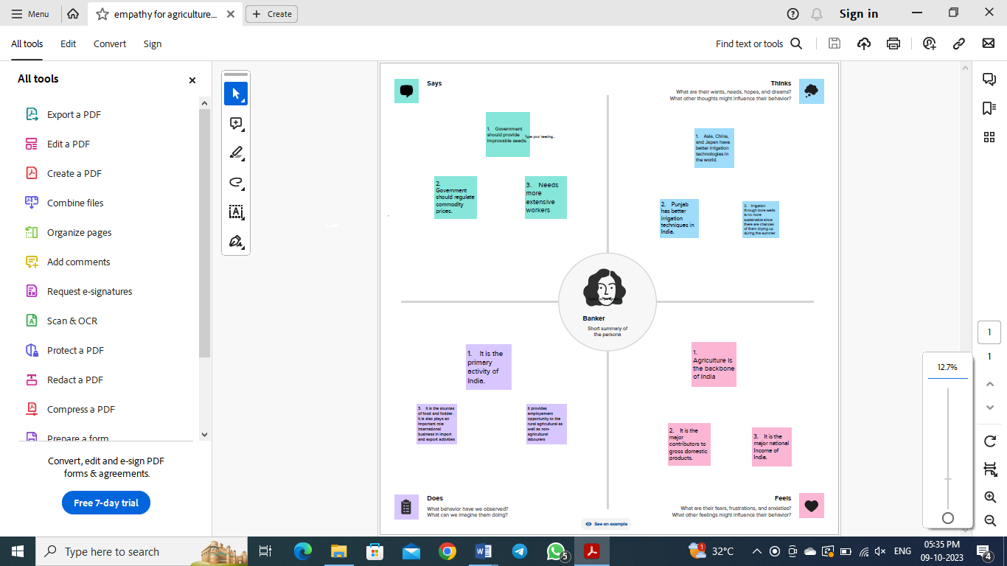

BRAINSTORMING MAP:

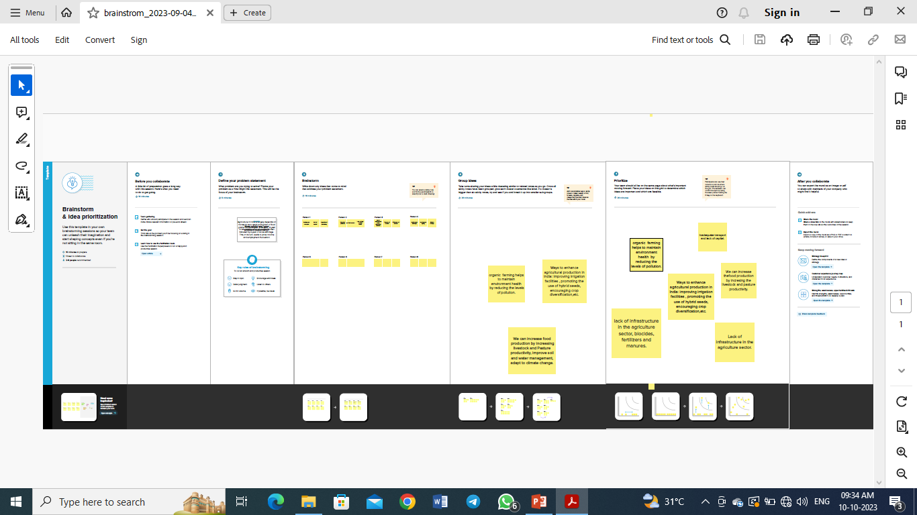

Result:

We created the data visualization such as dashboard and story using the dataset provided.

Dashboard:

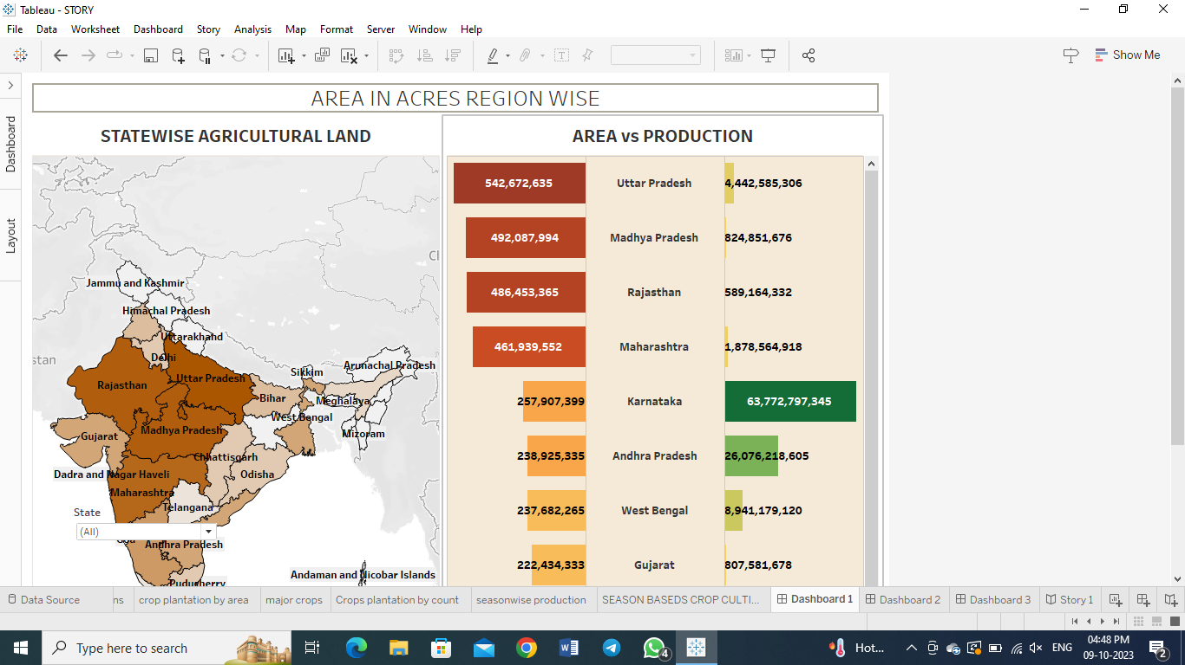

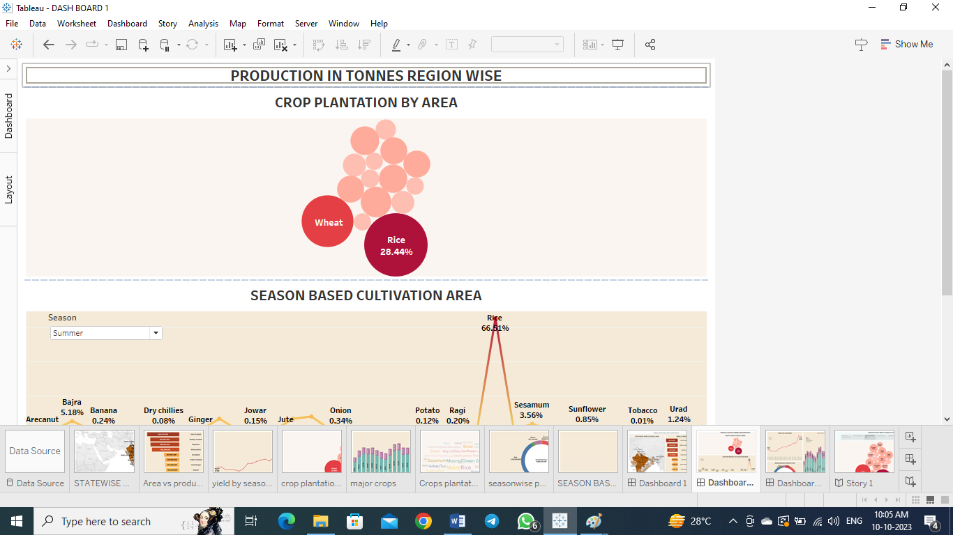

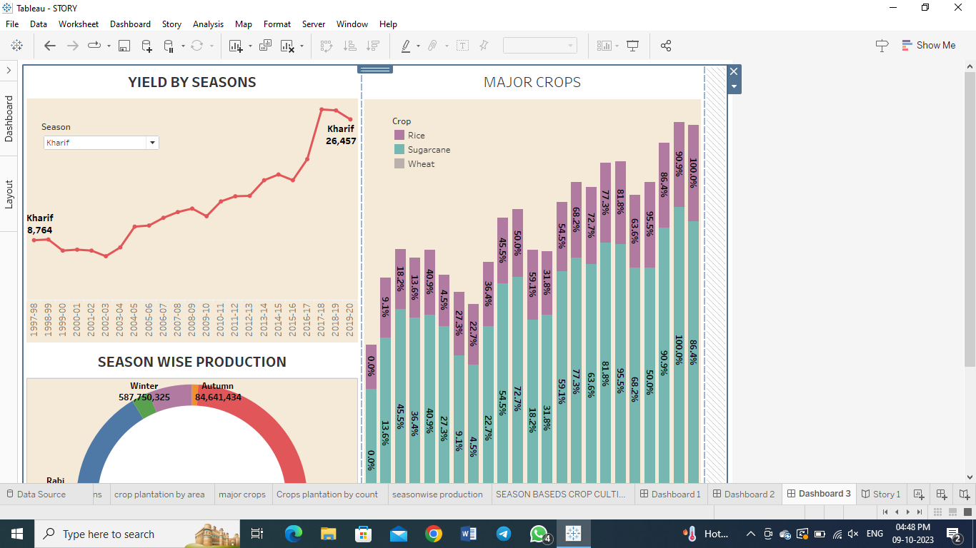

STORY:

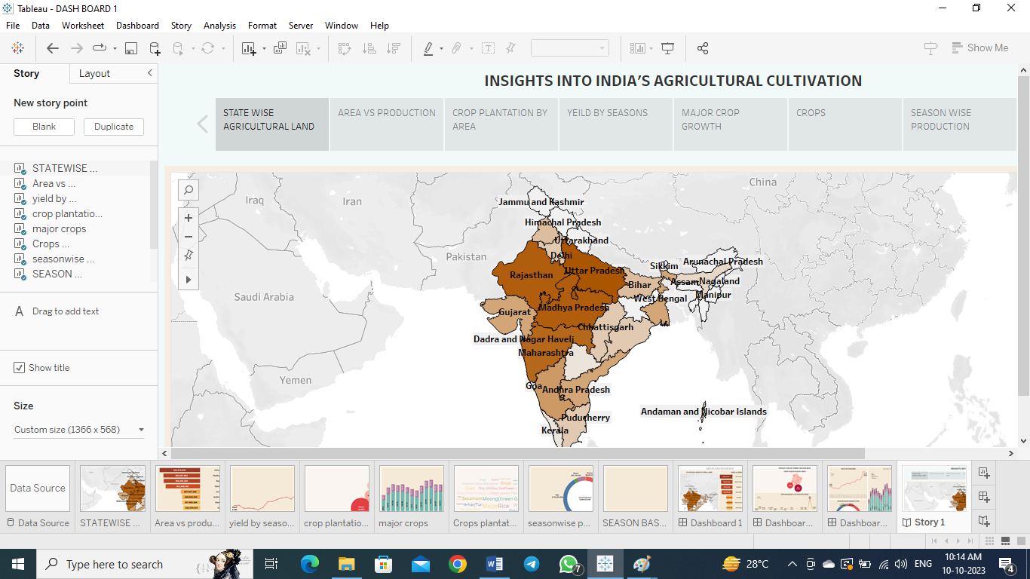

ADVANTANGES AND DISADVANTAGES OF INDIAN AGRICULTURE:

ADVANTAGES:

*Agriculture supplies raw materials to various agro-based industries like sugar, jute, cotton, textile and industries.

*Food processing industries are similarly depend on agriculture, therefore the development of these industries entirely is depend on agriculture.

*Agriculture impact society in many ways including supporting livelihood through food, habitat, and jobs.

*It provides raw materials for food and other products and building strong economies to trade.

*It provides employment opportunity to the rural agricultural as well as non-agricultural labourers.

DISADVANTAGES:

*Large scale, conventional farming focusses on intensive single crop production, mechanization, and depends on fossil fuels, pesticides, antibiotics and synthetic fertilizers. While this system yields high production level, it also contributes to climate change, pollutes air and water and depletes soil fertility.

*Erosion of soil by heavy rain, flood, insufficient vegetation cover etc., reduces farm productivity. Inadequate irrigation facilities and poor management of water resources have led to a great decline in agricultural productivity.

CONCLUSION:

The Indian economy is an agro economy and depends highly on the agricultural sector. Despite just supporting the Indian Economy, the agricultural sector also supports the industrial sector and international trade in imports and exports. The agricultural sector is of vital importance for the region it is undergoing a process of transition to a market economy, with substantial changes in the social, legal, structural, productivity and supply set – ups, as is the case with all other sectors of the economy.

FUTURE SCOPE:

Agriculture sector have an enormous scope in India as of the future reference because agricultural sector is the largest sector with 49% of the country’s population works in agricultural sector by occupation. India is also a developing country with about 16% of its GDP is contributed by this sector.

Indian agriculture can help the nation tackle three of its biggest challenges. They are,

*Feeding a huge and expanding population.

*Ensuring sufficient energy supplies.

*Curbing emissions.